# Q1. Top 10 Categories of Sales:

* Top Selling Category: With a total revenue of ZAR 11,90,108.34, Health and Beauty products lead the market sales of ShopNext Store, followed by a revenue of ZAR 11,67,738.18, watches gift accounts for the second highest revenue generator indicating a strong consumer interest in fashion and lifestyle products. Sports and leisure rank third with a total sale of ZAR 9,13,384.18.
* Bed Bath Table, Computers Accessories, cool stuff and furniture décor fall in the mid ranges of the total sales generated by ShopNext
* Toys, Garden Tools, and Baby are at the bottom of the list, especially Baby products with only ₹3,97,308.97, indicating low consumer demand or limited offerings.
* The combined total revenue across all categories is ₹1,24,24,423.25.
* The range of sales, i.e. Highest sales vs lowest sales, is significant, indicating uneven sales distribution.
* Special marketing attention should be given to the low performing categories like auto and toys to boost the sales.

# Q2. Delayed Order Analysis:

* The above image shows 20 most ordered products and their delivery analysis.
* Electronics, Baby products and office furniture show the maximum delay percentage which could indicate an issue with supply chain or logistics. Electronics items are generally high value items and hence there could be stringent QC associated with it and there could be limited inventory too. While Office furniture is bulky hence a possible delay is associated.
* In the top ordered products like bed bath table and health and beauty also show slightly higher than average delay rates.
* There are low delays in products which are small and easy to transport like pet products, fashion bags and cool stuff. Indicating better delivery reliability.
* ShopNext should put more emphasis on reducing delays in Baby, Electronics, and Office Furniture categories through better inventory management and vendor coordination.

# Q 3. Monthly Comparison of Delayed and on time Orders:

* High order volume was observed in the months of December, March, and May, with over 9K+ on-time orders each. While the lowest order volumes were seen in the months of September and October, indicating a seasonal dip in the orders.
* Delayed orders, significantly fewer, show slight peaks in January, March, and May, suggesting delivery challenges during or after high-volume periods. Despite the fluctuations the on-time orders remain constantly high throughout the year.
* March shows one of the highest delayed orders counts probably due to logistics stress during the financial year-end rush.

* Q2-18 and Q1-18 have the highest number of on-time orders (above 17K), indicating peak business activity.
* Delayed orders also peak in these two quarters, suggesting high demand may strain delivery capacity.
* Q4-16, Q4-17, and Q3-18 show strong performance with high order volumes and relatively fewer delays.
* Q1-17 and Q2-17 show moderate volumes with Q1-17 having a relatively higher delayed-to-on-time ratio, indicating early operational inefficiencies.
* Q4-16, Q4-17 show high order volumes with low delays, indicating operational efficiency.
* The logistics and inventory management should be strengthened in the high demand months and quarter like December, march. Models of Q4-17 and Q3-18 must be studied and replicated.

# Q4. Payment Method Analysis:

* Here the chart clearly shows that credit cards remain the preferred payment method, accounting for almost 73% of the total transactions, hereby indicating a strong consumer preference for flexible payments and good marketing for rewards.
* Boleto (a popular Brazilian payment method) is used in about 19% of transactions, showing that cash-based or offline payments still hold relevance for a significant customer base.
* Vouchers and debit cards are least used contributing to only 3.8%. It shows the lack of sufficient promotional campaigns and restricted usage.

# Q5. Product Rating Analysis:

* With an average rating of 4.67 CDs, the DVDs musical category remains the top-rated product category. This could be because categories like this appeal to the emotional side of a customer. Children’s clothes are also highly rated, suggesting that customers are satisfied with the quality, fit and comfort of the products.
* We can also see that 3 out of 10 top rated categories belong to books indicating reader satisfaction with the customer. Fashion (Sport) and Construction Tools receive strong ratings, suggesting these items deliver on performance and durability expectations.

* Security and Services drastically underperform and there could be many reasons for the same. There could be due to unreliable or poor-quality of services, safety or trust issues or it could be miscommunication or unmet expectations. A further analysis of the text review is required to understand what went wrong.
* Office Furniture & Comfort Categories also under performed maybe due to issues of product quality, comfort or durability. As we have seen that these categories were generally delivered late, which could be another possible reason for a low rating among the customers.
* Fashion Categories for Both Genders Rated Low suggest that there is a size/fit mismatch, material quality, or style variance from product images.
* Urgent review is required for the security and services category, also vendor partnership needs to be reviewed to improve the review performance of fashion and furniture. QA checks and test purchases must be introduced for hygiene and safety categories as this is a rather sensitive category.

# Q6. State-Wise sales analysis:

* The above image shows the top 6 high revenue producing states. SP (Sao Paulo) tops the chart with the highest revenue generating states accounting for almost 38% of the total revenue. These 6 states together contribute a significant share of total nationwide sales showing regional concentration.
* The marketing efforts in these areas should be doubled to retain or even increase the sales.

* The above image shows the bottom 6 states in terms of revenue generation. These are predominantly northern states like Roraima, Amapá, and Acre, possible because of lower population density, logistic challenges and limited digital penetration.
* Logistic improvements such as setting up local warehouses should be prioritized along with localized promotions to expand the reach in Northern regions along with understanding customer behavior to drive the marketing in these regions.

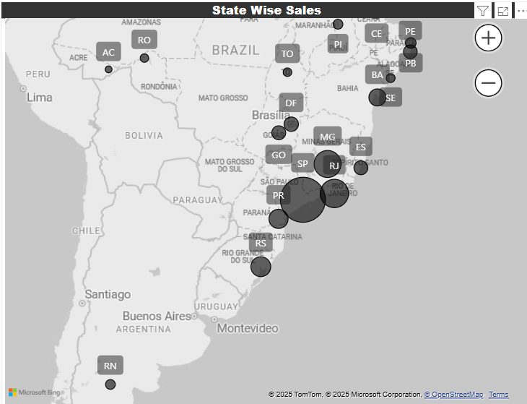

# Q7. Revenue by Quarter Year:

* Q2-18 shows strong revenue growth compared to the first quarter of the same year. The revenue amounts to 24.25 million, indicating good sales in the months of May and April. Post-holiday continues the momentum gained in the previous quarters. Also, a new financial yar starts, indicating a tendency of people to buy more in this period. This could also mean that the sustained marketing practices have proved fruitful.
* We can also notice that the year 2017 was great in terms of increasing the revenue consistently. Right from Q1-17 to Q4-17 the revenue rose gradually gaining momentum. Although the baseline is low it might be due to limited market presence and lack of an established customer base. The increase in revenue over the years suggests that the expansion efforts were working all fine. The brand was successful in increasing customer acquisition and retention.
* The store needs to improve Q3-18’s performance as this quarter sees a drop in revenue. Maybe the drop was because of market saturation, lack of offers or poor season of sales or maybe an internal operation slowdown. To improve the mid-year sales new offers and schemes must be introduced and the store must use budget marketing and forecast planning should be implemented.

# Q8. Revenue Analysis by Year:

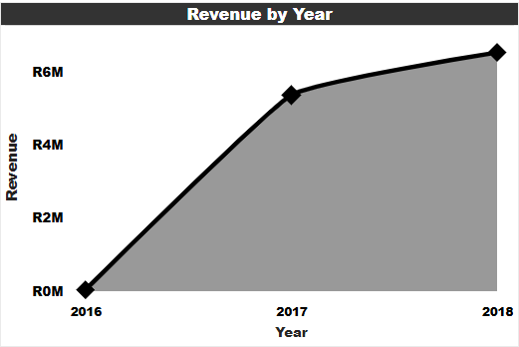

* Explosive growth was seen from 2016 to 2017 likely due to the business having just launched or because of the scaling up. These sales were sustained in the next financial year too ie 2018